PROJECT REPORT

1 INTRODUCTION

* 1. Overview

With the help of ZOHO Books of accounts we created profit and loss account and balance sheet and GST (18%) calculated for the Bright Ideas Consulting.

* 1. Purpose

It is created for the purpose of prepare Profit and Loss Account, Balance sheet and prepare GST Report for the Bright Ideas Consulting.

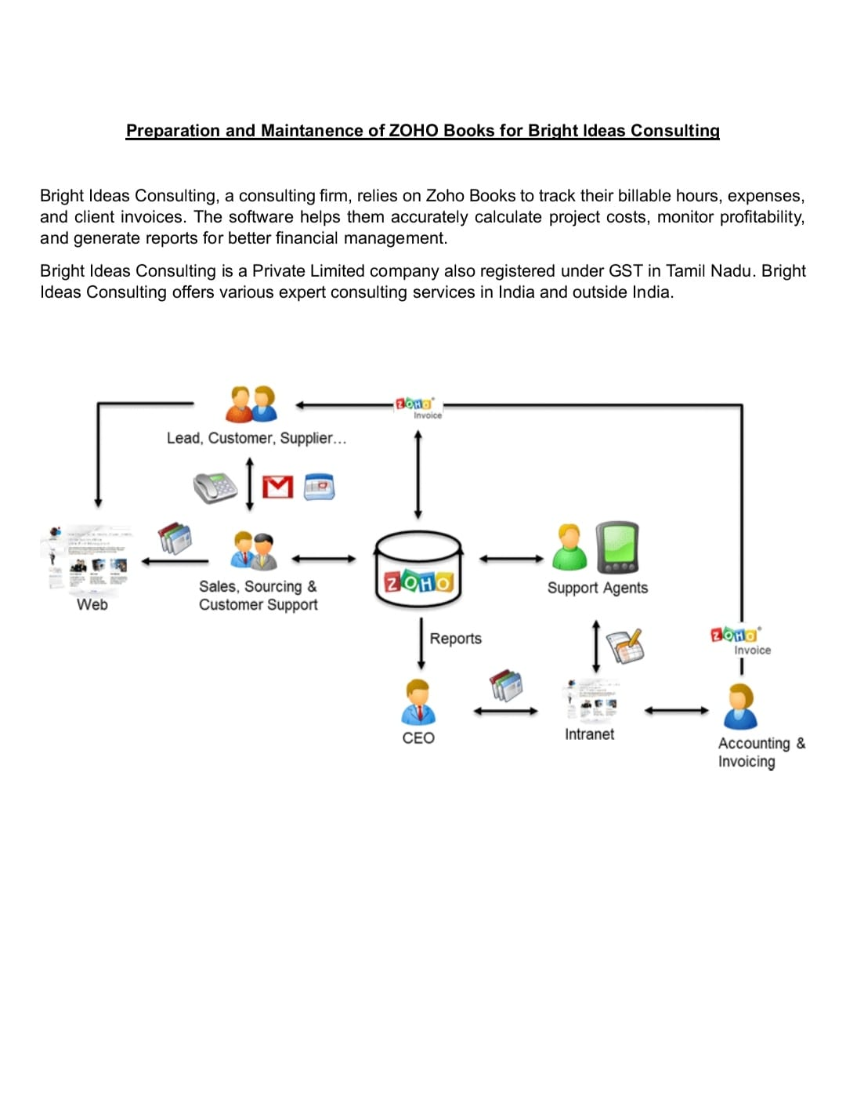

PROBLEM DEFINITION & DESIGN THINKING

It is created method of preparation of accounting profit and loss account balance sheet and GST calculation is complicated.

In Recent day’s new technologies allotted. Here we use ZOHO books as a tool for creating Profit and loss account, balance sheet and GST report.

2.1 Empathy Map

2.2 IDENTION & BRAINSTORMING MAP

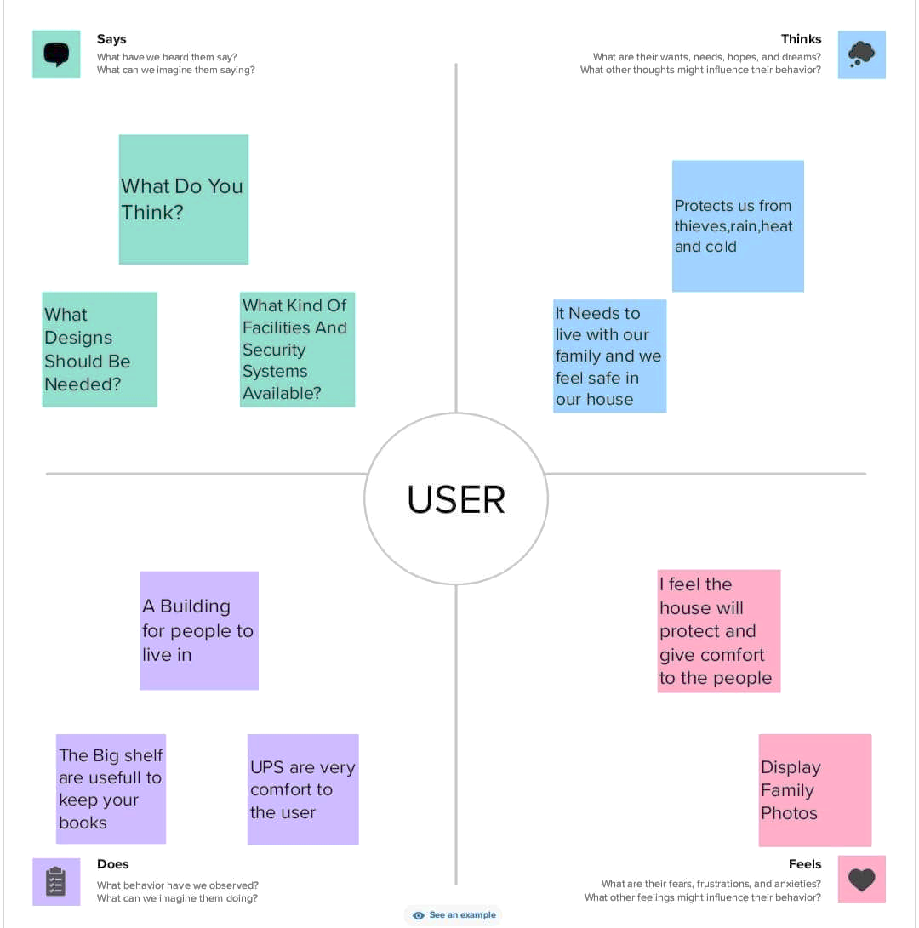

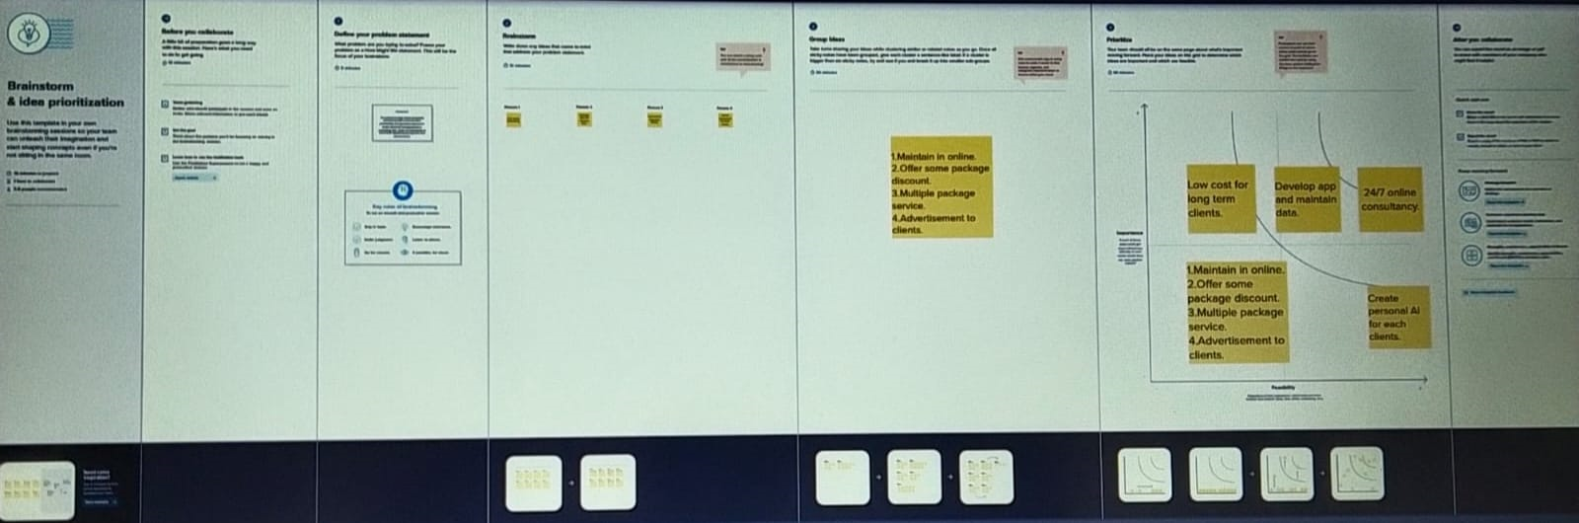

RESULT

Output:

1.Company Name Creation:

We have to create An Company Name And other details From Below ZOHO Books

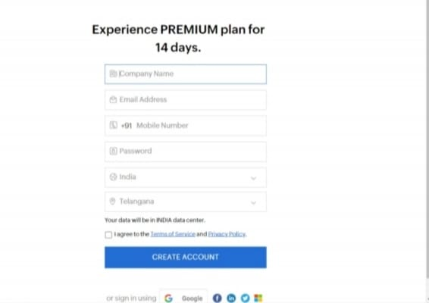

2. Item Creation:

We have to create items, Such as

\* Items names

\* Units

\*HSN/SAC

\*Selling info/Purchase info

\*Tax Rate

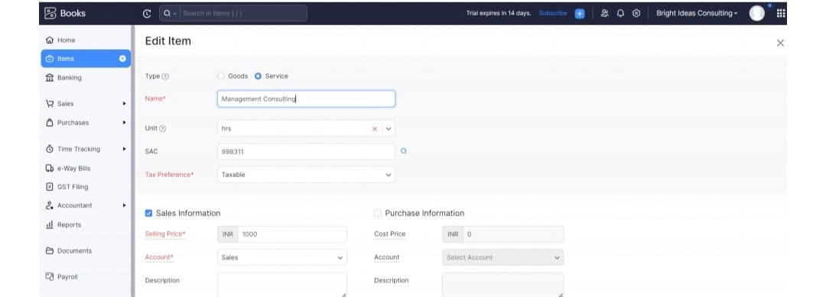

3. Vendor Creation:

Now create vendor in books from navigator panel Create New Vendor For example

\*Raj Kamal External Consulting

\*Amazon Web Services

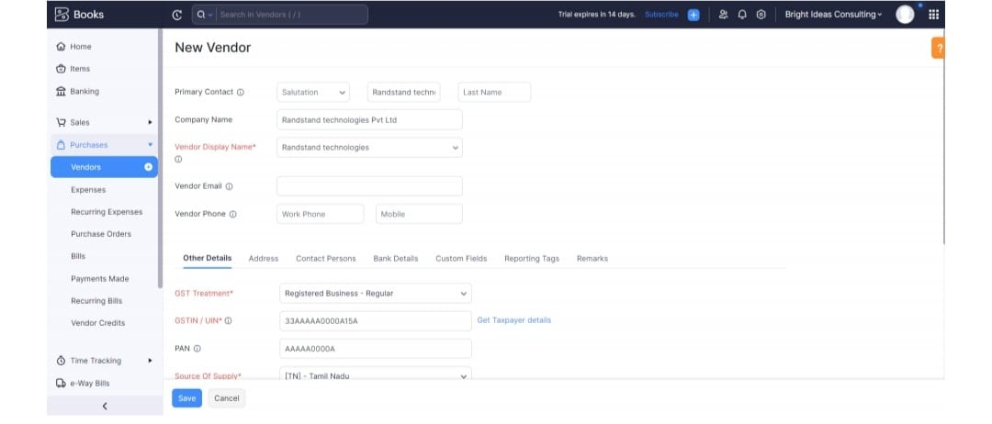

4. Purchase Order:

We are creating new purchase order such as below

\* Rand stand Technologies

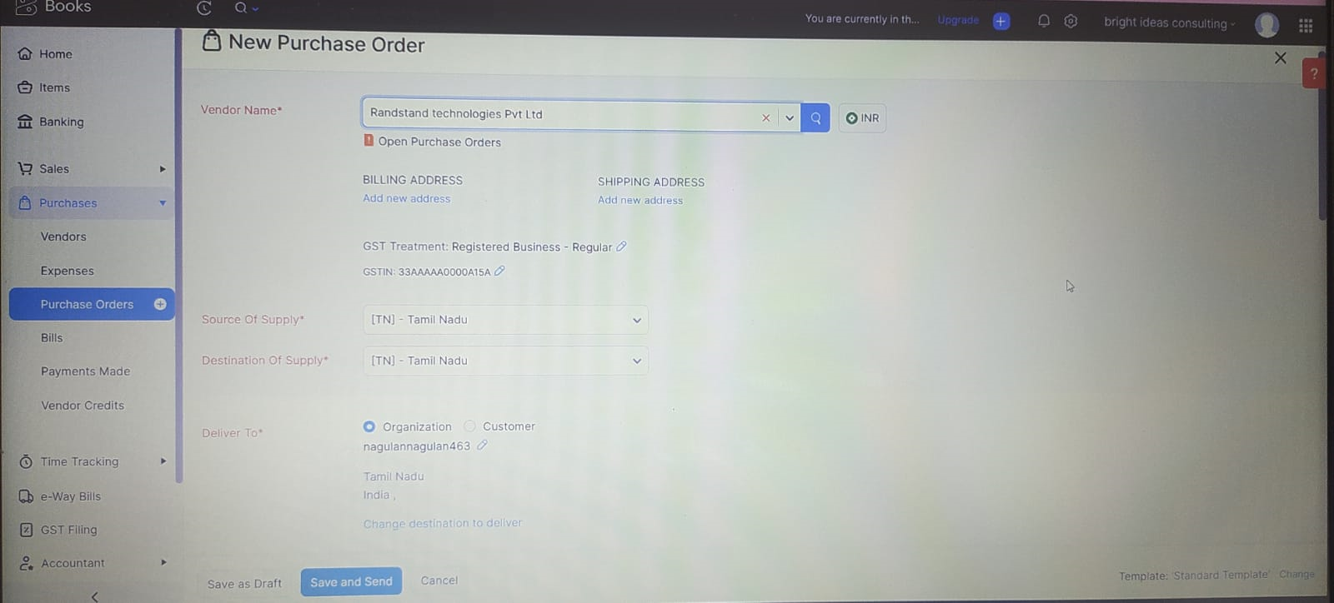

5.Sales Order:

Tech Wise Solutions Pvt Ltd received below sales order from mentioned customer

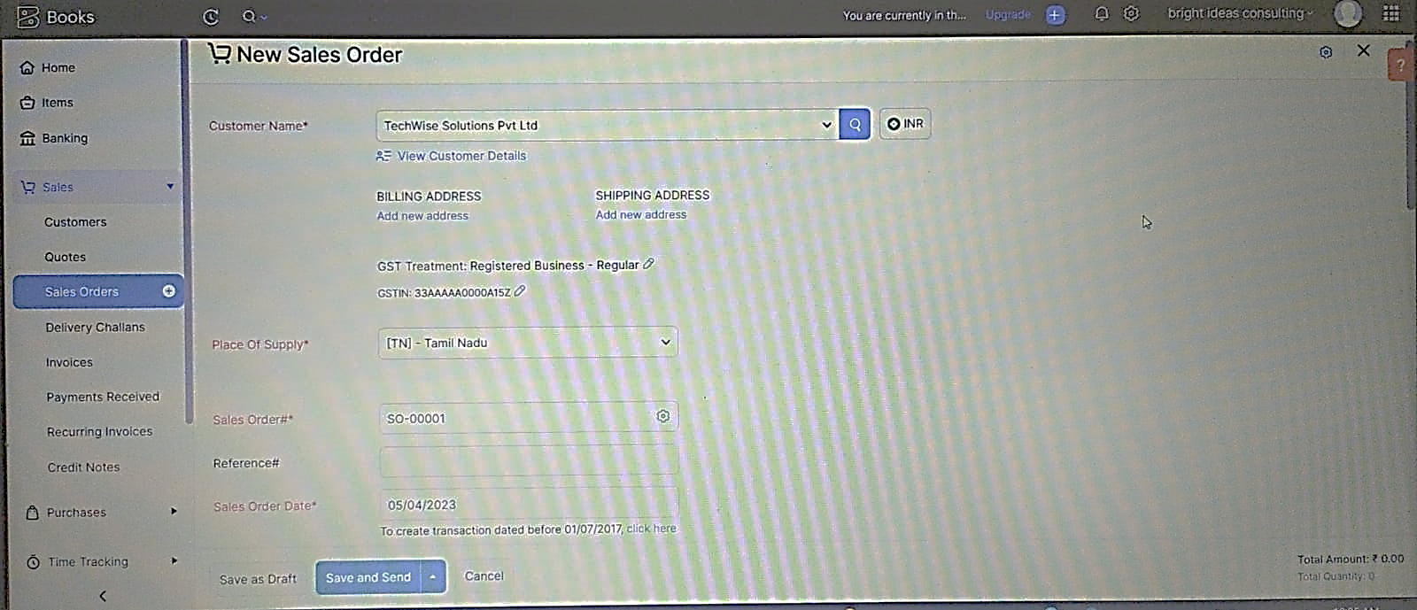

6.Payment to Bank Details:

Tech Wise Solutions Pvt Ltd has opened an account with ICICI bank, to add the bank account and we have to select bank account manually and filled it.

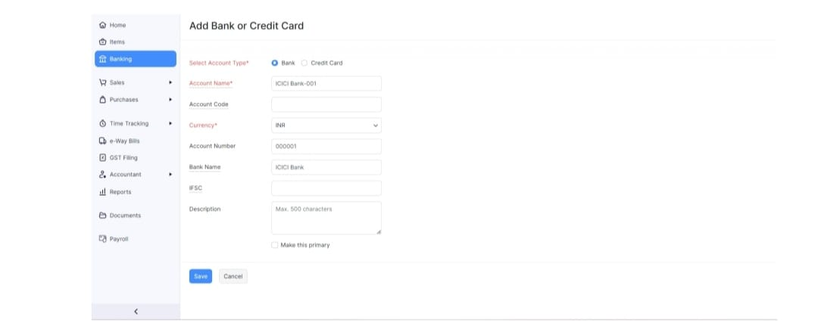

7.Profit and Loss Account/Balance Sheet/GST Report:

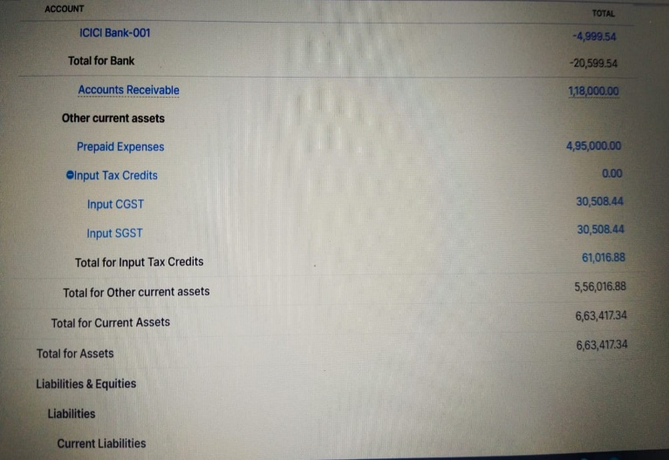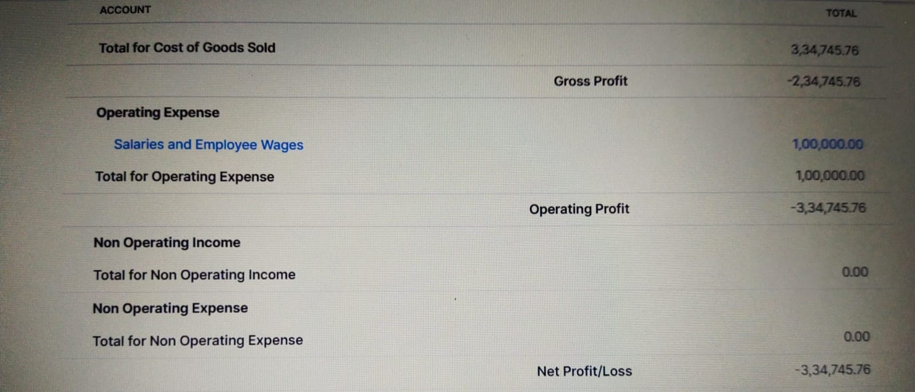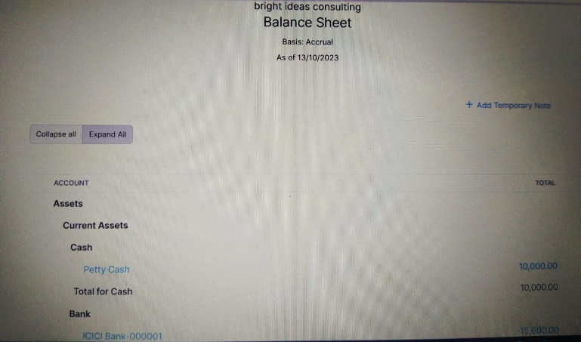

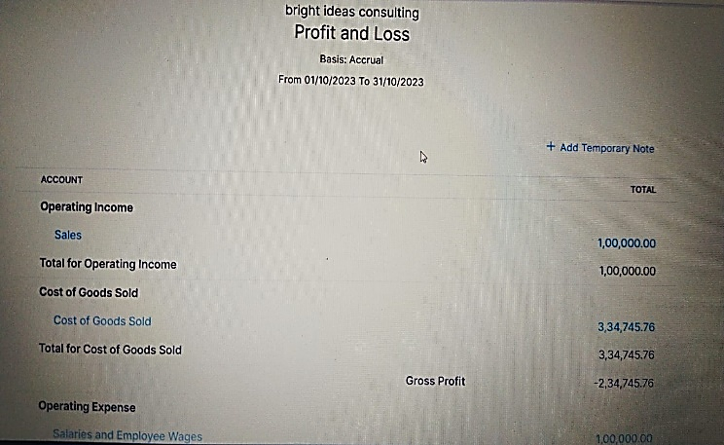

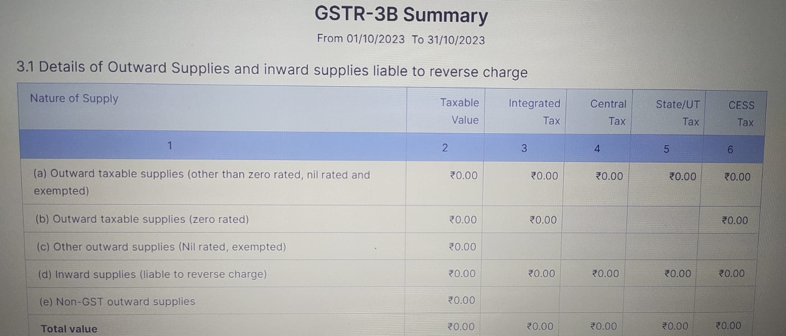

4 ADVANTAGE & DISADVANTAGE:

ADVANTAGE: A combination of both to generate a competitive advantage

DISADVANTAGE: Missing New Version

5) APPLICATION:

This application used to maintain the companies details and ledger accounts profit and loss Account and Balance sheet of the company Tech Wise Solutions.

6) CONCLUSION:

Tech Wise Solutions is where a city’s form Features converge. By implementing well- conceived designs of principles, communities are functioned.

7 FUTURE SCOPE:

In upcoming year digitalization is the future. Most of the companies are computerised for many reasons. Maintaining accounts are also computerised in future. With these new Technology preparation of company details. Accounting software was user friendly Ant it can be adopted.

8) APPENDIX:

\*Approved development

\*Future Assessment

\*Plan of development

\*Development Purpose

\*Interpretation